**Assignment #3. Advanced CSS ( Flexbox & Grid)**

Student: Gaziza Bakir

Group: SE-2439

[**https://gazizkaa.github.io/asik3/**](https://gazizkaa.github.io/asik3/)

**Part 1. Flexbox**

Navigation Bar: I created a header with a logo on the left and navigation links on the right. Using Flexbox, I aligned the logo and links horizontally, centered them vertically, and applied spacing between the links.

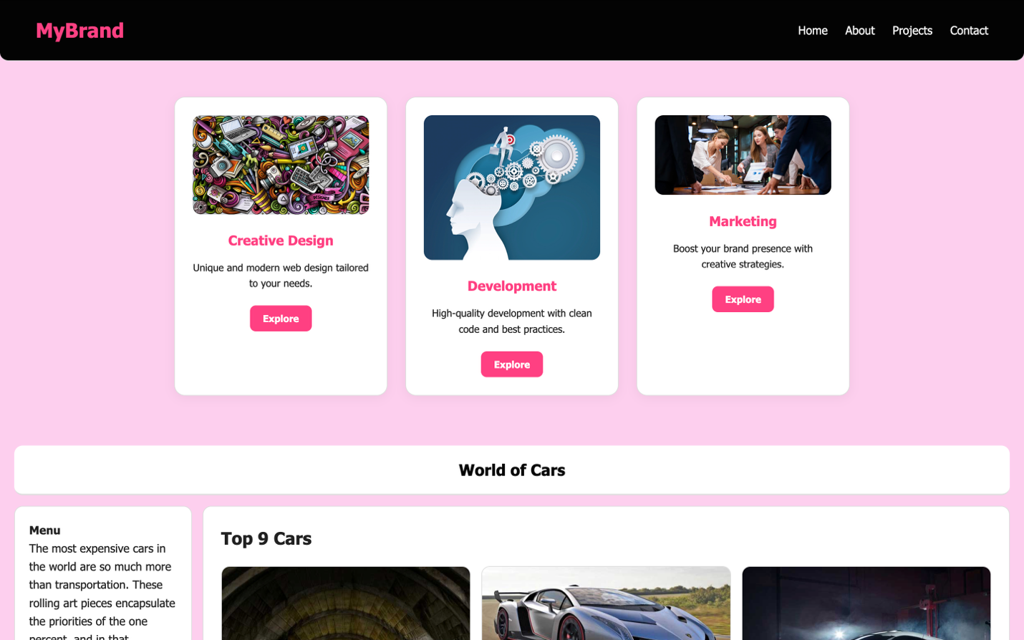

Card Row: I designed a row of three cards, each containing an image, title, text, and a button. Flexbox ensured equal card heights, consistent gaps, and smooth hover effects for interactivity.

**Part 2. Grid System**

Page Layout: I structured the page with a header, sidebar, main content area, and footer using CSS Grid. Grid areas were correctly assigned to ensure logical placement and spacing.

Image Gallery: I implemented a gallery of nine images arranged in a clean, uniform grid. Hovering over images reveals captions, improving usability and style.

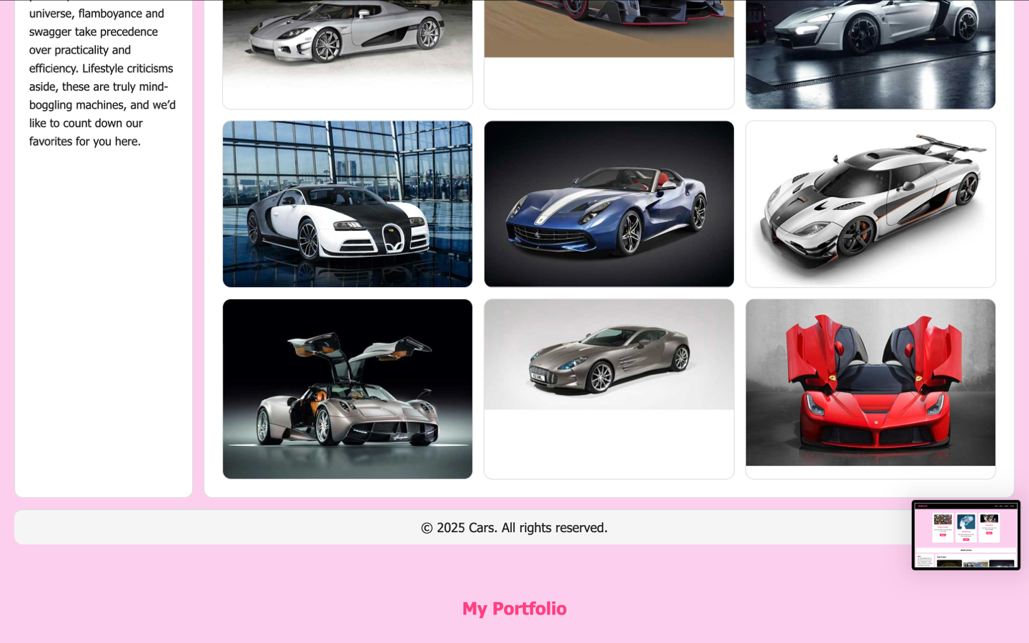

**Part 3. Combining Flexbox & Grid**

Portfolio Page: I created a portfolio page that combines Flexbox and Grid. The header uses Flexbox for navigation, while the main section is a Grid with a projects area on the left and sidebar information on the right. Inside project cards, Flexbox organizes titles, descriptions, and buttons. The layout is consistent, responsive, and visually appealing.

